# Exercises: JS Libraries

Problems for exercises and homework for the [“JavaScript for Front-End” course @ SoftUni](https://softuni.bg/trainings/1795/javascript-for-front-end-october-2017).

You will have to do a few simple tasks using whatever libraries we can think of. You’ve seen pretty much all that is needed to implement these tasks.

## Simple Accordion

An Accordion is a quite frequently used front-end element. It represents a menu of items, which expand and collapse upon clicking. Your task is to implement a very simple accordion using **HTML**, **CSS** and **JavaScript**.

The accordion should look like this:

### Picture 1

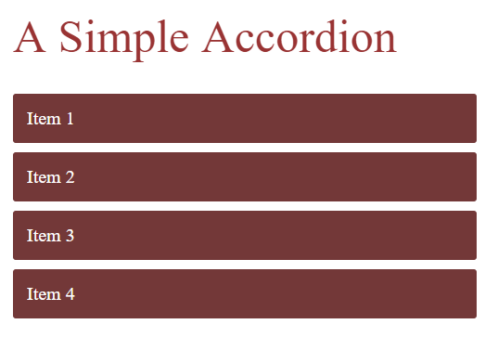

### Picture 2

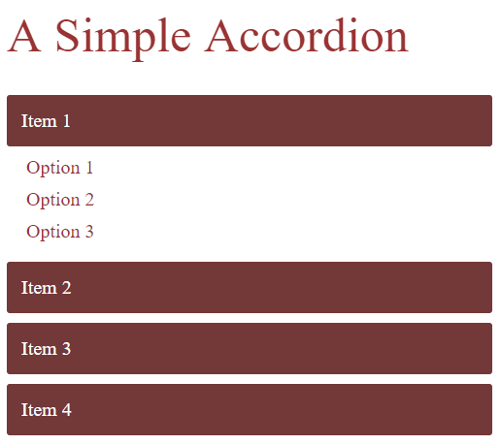

### Picture 3

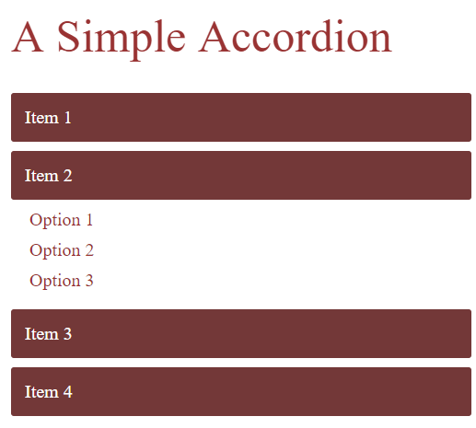

Upon **CLICKING** a **different item**, the **previously expanded** one **SHOULD COLLAPSE**.

There are no specific fonts, font-sizes, widths, heights, margins etc. Even the colors are not specific. Basically there are **NO specific HTML & CSS rules**. Just make sure it looks like the pictures above. In the resources you’ll find a **gif** of its **functionality**.

The **items** and the **inner items** can be **added statically** in the **HTML**.

## Nested Accordion

Using what was done in the previous task, create an **accordion** which supports nested inner items. Like this:

### Picture 1

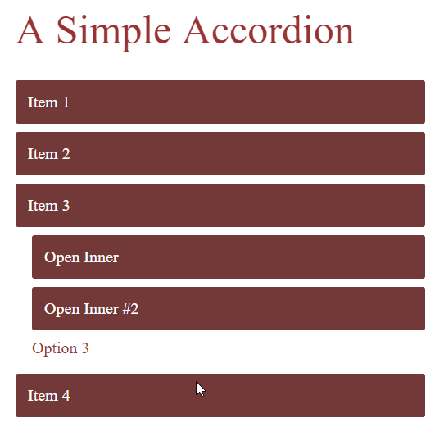

### Picture 2

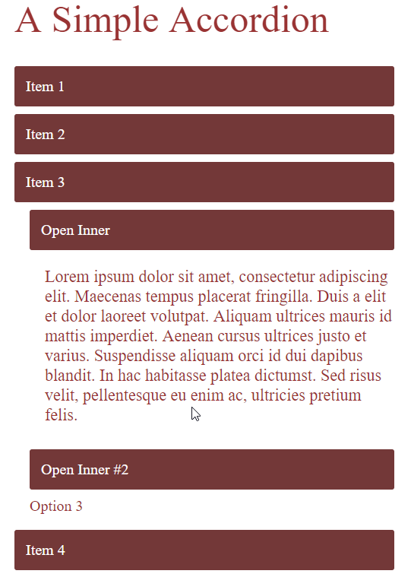

### Picture 3

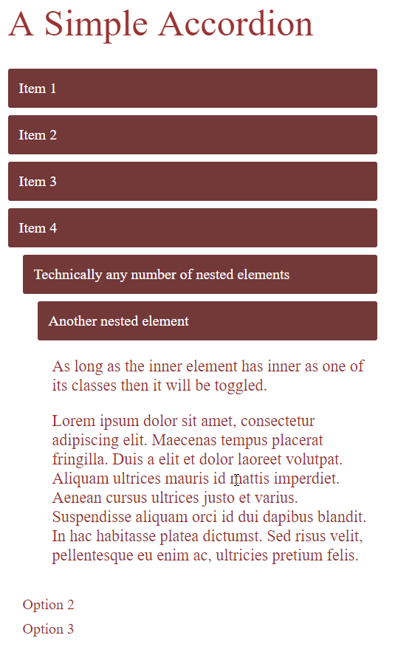

You will find a **gif** in the **resources** for how it should work too.

## Simple Slider

Implement a Simple Slider using the HTML, CSS, JavaScript and the JS libraries you’ve learnt till now.

### Example Slider IExample Slider II

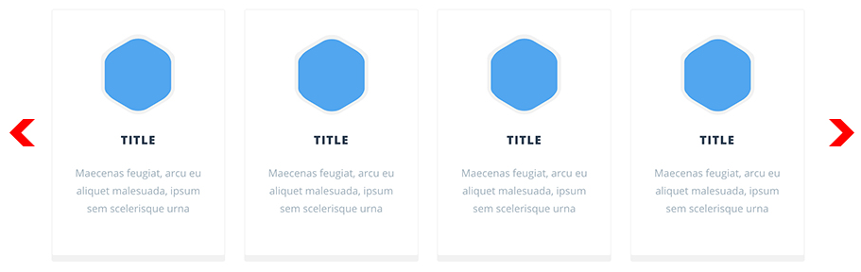

### Example Slider III



### The slider should have:

* **Several items** (may be statically encoded in the HTML)
* A **[Previous]** and **[Next]** buttons (may be only **ARROWS**)
* **Animation** upon sliding. (it should be a smooth slide, not just lightning-fast teleportation slide)
* [**BONUS TASK**] **Auto-slide** every 5 seconds. The slider should slide once to the **RIGHT** every 5 seconds. **NOTE**: The 5 second count should **RESTART** upon **manual sliding**. In other words, if the **user** slides manually at the **4th second**, there should **NOT** be another slide after **1 second**.

A **gif** has been added to the resources showing you how it should look.

Implement the tasks and submit your homework on the **course page**. Your Homework **WILL BE CHECKED**, so do not submit **empty** homework.